Swaminarayan University
Subject: F. AI
SEM: 5th SEM CE
UNIT-1

List out the applications of AI.

✅ 1. Healthcare
- Disease Diagnosis: AI systems analyze medical images (X-rays, MRIs) to detect diseases like cancer, pneumonia, etc.
- Drug Discovery: AI speeds up the process of developing new drugs by analyzing complex biological data.
- Virtual Health Assistants: Chatbots and AI assistants help patients with reminders, symptoms checking, and medication.
- Robotic Surgery: Robots powered by AI assist doctors in performing precise surgeries.
- Predictive Analytics: Forecast outbreaks or patient deterioration using historical and real-time data.

✅ 2. Education
- Personalized Learning: AI customizes learning experiences based on a student's strengths and weaknesses.
- Automated Grading: AI evaluates student tests and assignments automatically.
- AI Tutors: Virtual tutors guide students through complex subjects.
- Language Translation: AI translates educational content into different languages.
- Student Performance Prediction: Predicts outcomes and helps in early intervention.

✅ 3. Transportation
- Autonomous Vehicles: Self-driving cars use AI to navigate, recognize objects, and make decisions.
- Traffic Management: AI predicts congestion and controls traffic signals for better flow.
- Fleet Management: Optimizes routes and fuel consumption in logistics.
- Drones: AI-enabled drones are used for deliveries, surveillance, and rescue missions.

✅ 4. Finance
- Fraud Detection: AI identifies unusual patterns in transactions to detect fraud.
- Algorithmic Trading: AI systems trade stocks based on data patterns.
- Credit Scoring: Evaluates loan eligibility using more accurate models.
- Customer Service Bots: AI chatbots handle banking queries 24/7.
- Robo-Advisors: Automated platforms that provide financial advice and manage portfolios.

✅ 5. Manufacturing
- Predictive Maintenance: AI predicts equipment failures before they happen.
- Quality Control: Computer vision detects product defects on the production line.
- Industrial Robots: AI-powered robots handle repetitive and dangerous tasks.
- Process Optimization: Improves efficiency and reduces production costs.

✅ 6. Agriculture
- Crop Monitoring: AI analyzes satellite and drone imagery to monitor crop health.
- Pest Detection: Identifies signs of disease and pests early.
- Smart Irrigation: AI automates watering schedules based on weather and soil data.
- Yield Prediction: Forecasts harvest outcomes to help planning and logistics.

✅ 7. Entertainment
- Content Recommendation: Netflix, YouTube, and Spotify use AI to recommend personalized content.
- Video Game AI: AI controls NPC behavior for more realistic gaming.
- Content Creation: AI generates music, scripts, and even films.
- Deepfakes: AI creates realistic fake videos for entertainment and creative use.

✅ 8. Retail and E-Commerce
- Personalized Recommendations: Suggests products based on user behavior.
- Chatbots: Handle customer queries and orders 24/7.
- Inventory Management: AI predicts demand and automates stock management.
- Visual Search: Users can search using images instead of text.

✅ 9. Security and Surveillance
- Facial Recognition: Identifies individuals in real-time through cameras.
- Behavior Monitoring: Detects suspicious behavior in public places.
- Intrusion Detection Systems: AI secures computer networks by identifying threats.
- Video Analytics: Analyzes CCTV footage for actionable insights.

✅ 10. Natural Language Processing (NLP)
- Language Translation: AI translates text and speech across languages (e.g., Google Translate).
- Speech Recognition: Used in assistants like Alexa, Siri, and Google Assistant.
- Text Summarization: Automatically shortens long documents while keeping key points.
- Sentiment Analysis: Understands user opinions on social media and reviews.

✅ 11. Smart Home and IoT
- Smart Assistants: Devices like Alexa and Google Home use AI to perform tasks on command.
- Energy Management: AI manages energy use in homes for efficiency.
- Home Security: AI monitors camera feeds and alerts homeowners.

✅ 12. Robotics
- Humanoid Robots: Robots that assist in customer service, elderly care, and hospitality.
- Warehouse Robots: Used by companies like Amazon to pick, pack, and sort products.
- Disaster Response: Robots navigate dangerous areas to aid in search and rescue.

✅ 13. Autonomous Vehicles
- Self-driving Cars: Use AI to perceive surroundings, make driving decisions, and avoid obstacles.
- Public Transport: AI helps plan and optimize public transit routes.

✅ 14. Customer Service
- AI Chatbots: Instantly answer customer questions and handle complaints.
- Virtual Call Centers: AI routes and handles calls efficiently without human agents.

✅ 15. Cybersecurity
- Threat Detection: Identifies and prevents cyberattacks before they happen.
- Anomaly Detection: Finds unusual behavior that may indicate a data breach.

✅ 16. Environment and Sustainability
- Climate Prediction: AI models simulate climate change and help plan mitigation.
- Waste Management: AI optimizes recycling processes.
- Wildlife Protection: Tracks animal movements and prevents poaching.

Define AI and Discuss AI Techniques.
What is an AI Technique?
Artificial Intelligence (AI) refers to developing computer systems for performing tasks requiring human intelligence. These systems assess large amounts of data to identify patterns and make logical decisions based on the collected information. The ultimate goal of AI is to create machines to carry out diverse tasks.
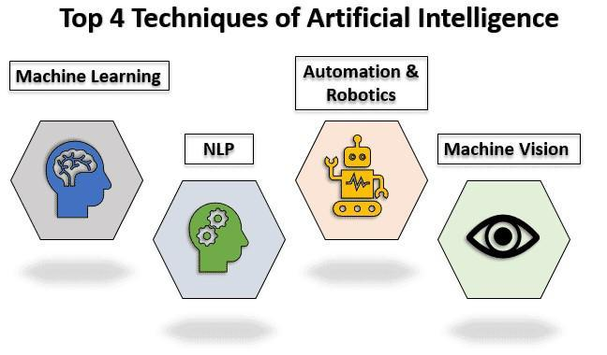
Artificial Intelligence techniques refer to a set of methods and algorithms used to develop intelligent systems that can perform tasks requiring human-like intelligence. Some of the widely used ones are:
- Machine Learning.
- Natural Language Processing.
- Computer Vision.
- Deep Learning
- Data Mining
- Robotics.
Machine Learning:
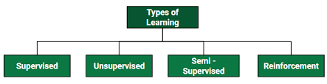
This approach involves the building of algorithms to learn patterns in data and make predictions based on it.
1. Unsupervised machine learning -AI systems analyse unlabelled data, where no predefined outcomes are provided. The objective is to uncover inherent structures or patterns within the data without any prior knowledge. For instance, it can group similar customer behaviour data to identify customer segments for targeted marketing strategies.
2. Supervised learning - A combination of an input data set and the intended output is inferred from the training data. AI systems learn from a labelled dataset, where each data point is associated with a known outcome. For instance, it enables email spam filters to distinguish between spam and legitimate emails based on learned patterns.
3. Semi-supervised learning - It is a method that uses a small amount of labelled data and a large amount of unlabelled data to train a model. The goal of semi-supervised learning is to learn a function that can accurately predict the output variable based on the input variables, similar to supervised learning. However, unlike supervised learning, the algorithm is trained on a dataset that contains both labelled and unlabelled data.
4. Reinforcement learning - In RL, the data is accumulated from machine learning systems that use a trial-and-error method to learn from outcomes and decide which action to take next. After each action, the algorithm receives feedback that helps it determine whether the choice it made was correct, neutral or incorrect. It performs actions with the aim of maximizing rewards, or in other words, it is learning by doing in order to achieve the best outcomes.
Natural Language Processing:
Natural Language Processing involves programming computers to process human languages to facilitate interactions between humans and computers.
However, the nature of human languages makes Natural Language Processing difficult because of the rules involved in passing information using natural language. NLP leverages algorithms to recognize and abstract the rules of natural languages, converting unstructured human language data into a computer-understandable format.
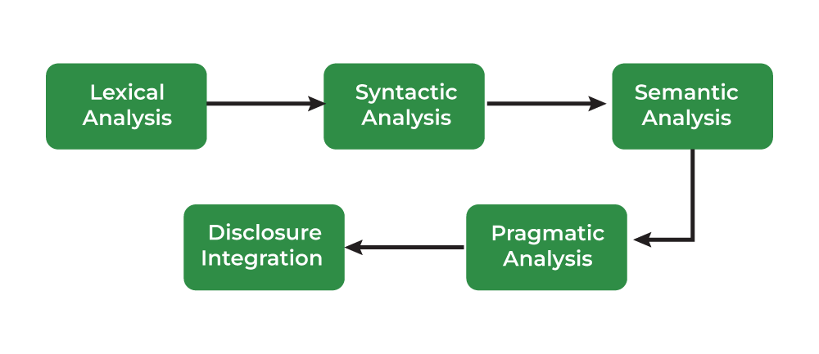

Applications of Natural Language Processing can be found in IVR systems and applications used in call centres, language translation applications like Google Translate, and word processors such as Microsoft Word to check the accuracy of grammar in text.
Some of the common variants of NLP are:
1. Lexical integration - Lexical analysis is the process of converting a sequence of characters into a sequence of tokens. A lexer is generally combined with a parser, which together analyses the syntax of programming languages, web pages, and so forth. Lexers and parsers are most often used for compilers. The text or sound waves are segmented into words and other units.
2. Syntactic integration - Syntactic analysis is the process of analysing a string of symbols, either in natural language, computer languages, or data structures, conforming to the rules of formal grammar. It is used in the analysis of computer languages, to facilitate the writing of compilers and interpreters. Grammatical rules are applied to categories and groups of words, not individual words. It is a crucial part of NLP.
3. Semantic integration - Semantic Analysis attempts to understand the meaning of the human language. It captures the meaning of the given text while considering context, logical structuring of sentences, and grammar roles.
2 parts of Semantic Analysis are:
- Lexical Semantic Analysis
- Compositional Semantics Analysis.
4. Pragmatic integration - Pragmatic Analysis is part of the process of extracting information from text. It focuses on taking a structured set of text and figuring out the actual meaning of the text. It also focuses on the meaning of the words of the time and context.
Effects on interpretation can be measured using PA by understanding the communicative and social content from the given text.
5. Disclosure integration - Discourse analysis is used to uncover the motivation behind a text and is useful for studying the underlying meaning of a spoken or written text as it considers the social and historical contexts of it. Discourse analysis is a process of performing text or language analysis, that involves text interpretation and an understanding of social interactions and customs.
Computer Vision:
Computer Vision equips machines with the ability to interpret visual information from the world. This technique has revolutionized industries like healthcare, automotive, and robotics, enabling tasks such as facial recognition, object detection, and autonomous driving. The extent to which it can discriminate between objects is an essential component of machine vision.
Sensitivity in computer vision is an AI application’s ability to pick out small details in visual information. A low-sensitivity system may not pick up subtle clues in images or fail to work well in low lighting. However, high sensitivity might be able to look at an image’s fine details and pick up on information other systems might miss. A common example is Surveillance systems.
Resolution is the level of detail a computer vision system can capture and process. High-resolution images are vital for correctly identifying an image’s detail.
Application of computer vision
Robotics & Automation:
Automation aims to enable machines to perform boring, repetitive jobs, increasing productivity and delivering more effective, efficient, and affordable results. To automate processes, many businesses employ machine learning, artificial neural, and graphs.
By leveraging the CAPTCHA technique, this automation can avoid fraud problems during online payments.
Robotic process automation is designed to carry out high-volume, repetitive jobs while being capable of adapting to changing conditions.
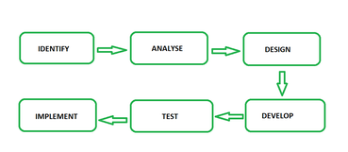
Deep Learning:
Deep learning is the branch of machine learning which is based on artificial neural network architecture. An artificial neural network or ANN uses layers of interconnected nodes called neurons that work together to process and learn from the input data.

In a fully connected Deep neural network, there is an input layer and one or more hidden layers connected one after the other. Each neuron receives input from the previous layer neurons or the input layer. The output of one neuron becomes the input to other neurons in the next layer of the network, and this process continues until the final layer produces the output of the network.
In computer vision, Deep learning models can enable machines to identify and understand visual data. Some of the main applications include the identification and locating of objects within images and videos.
Data Mining:
Data mining is the process of extracting knowledge or insights from large amounts of data using various statistical and computational techniques. The data can be structured, semi-structured, or unstructured, and can be stored in various forms such as databases, data warehouses, and data lakes.
Explain AI problems in detail.
Certainly! Here's a detailed explanation of AI problems, suitable for academic or classroom use:

✅ 3. Explain AI Problems in Detail
AI problems refer to the challenges and tasks that Artificial Intelligence systems aim to solve. These problems typically require human-like thinking, learning, and decision-making abilities. Solving them involves handling uncertainty, complexity, large data, and adaptability.

✅ Key Characteristics of AI Problems:
- Perception: Understanding the environment through sensors (e.g., camera, microphone).
- Reasoning: Drawing logical conclusions or making predictions.
- Learning: Improving performance from experience.
- Planning: Choosing a sequence of actions to achieve a goal.
- Acting: Executing actions effectively in a dynamic environment.

🔹 Categories of AI Problems (with Examples)

🔸 1. Search Problems
AI needs to explore different possible solutions or paths to reach a goal.
- Example: Solving a maze, chess moves, route planning in Google Maps.
- Challenge: Large number of possibilities (combinatorial explosion).
🔧 Techniques:
- Breadth-First Search
- Depth-First Search
- A* Algorithm

🔸 2. Knowledge Representation Problems
AI must represent complex real-world knowledge in a form a machine can understand.
- Example: Representing family relationships, legal rules, or medical symptoms.
- Challenge: Representing facts, rules, and relationships efficiently.
🔧 Techniques:
- Semantic networks
- Frames
- Ontologies
- Logic (propositional and predicate)

🔸 3. Reasoning and Inference Problems
AI must draw conclusions based on available knowledge.
- Example: Diagnosing diseases based on symptoms, legal decision-making.
- Challenge: Handling incomplete, uncertain, or contradictory information.
🔧 Techniques:
- Rule-based systems
- Fuzzy logic
- Bayesian inference

🔸 4. Learning Problems
AI systems learn from data to improve their performance.
- Example: Email spam detection, handwriting recognition, recommendation systems.
- Challenge: Quality of data, overfitting/underfitting, computational cost.
🔧 Techniques:
- Supervised learning
- Unsupervised learning
- Reinforcement learning

🔸 5. Natural Language Understanding
AI must interpret human language (spoken or written).
- Example: Language translation, voice assistants (Alexa/Siri), sentiment analysis.
- Challenge: Language ambiguity, grammar variations, context understanding.
🔧 Techniques:
- Natural Language Processing (NLP)
- Language models (e.g., GPT, BERT)
- Speech recognition

🔸 6. Perception Problems
AI must interpret sensory input such as images, sounds, or signals.
- Example: Face detection, object recognition, voice commands.
- Challenge: Poor lighting, background noise, distorted data.
🔧 Techniques:
- Computer vision
- Audio signal processing
- Sensor fusion

🔸 7. Planning and Decision-Making Problems
AI needs to plan and decide how to achieve goals efficiently.
- Example: Robot movement, warehouse automation, scheduling.
- Challenge: Dynamic environments, time constraints, unexpected obstacles.
🔧 Techniques:
- STRIPS (planning language)
- Markov Decision Process (MDP)
- Game theory

🔸 8. Robotics and Action Problems
AI controls robots to act in the real world.
- Example: Self-driving cars, drone delivery, industrial robots.
- Challenge: Real-time response, safety, multi-sensor coordination.
🔧 Techniques:
- Reinforcement learning
- Path planning algorithms
- Motion control

🔸 9. Multi-Agent Problems
Involving multiple AI agents that cooperate or compete.
- Example: Online multiplayer games, smart traffic systems.
- Challenge: Coordination, communication, negotiation, game-theoretic strategies.
🔧 Techniques:
- Agent-based modelling
- Distributed AI
- Swarm intelligence

🔸 10. Ethical and Social Challenges
Issues that arise from using AI in real-world scenarios.
- Example: AI bias in hiring, privacy in surveillance, autonomous weapon systems.
- Challenge: Fairness, accountability, transparency.
🔧 Approach:
- AI ethics frameworks
- Human-in-the-loop systems
- Legal and policy development

✅ 4. List of AI Problem Characteristics
AI problems often differ from traditional computing problems due to their complexity, uncertainty, and the need for human-like reasoning. Below are the key characteristics:

🔹 1. Perception and Interpretation
- AI problems often involve interpreting data from the environment (e.g., images, speech, sensors).

🔹 2. Incomplete and Uncertain Information
- Information may be missing, noisy, or uncertain.
- The system must make probabilistic decisions.

🔹 3. Heuristic Search
- AI often relies on heuristic methods (rules of thumb) to explore possible solutions efficiently.

🔹 4. Combinatorial Explosion
- The number of possible states or solutions can be very large.
- Efficient algorithms are needed to avoid exhaustive search.

🔹 5. Multiple Solutions
- There may be more than one acceptable or optimal solution.
- AI chooses the most appropriate solution based on context.

🔹 6. Knowledge Representation
- AI problems require a way to represent real-world knowledge in formats understandable by machines (e.g., logic, rules, semantic networks).

🔹 7. Learning from Experience
- AI systems learn and improve over time using past data and feedback.

🔹 8. Goal-Oriented
- AI problems are usually defined with a specific goal or objective to achieve.

🔹 9. Reasoning and Decision Making
- AI must use logical inference or probability to draw conclusions and make decisions.

🔹 10. Dynamic Environment
- The problem space may change over time, requiring adaptive responses.

🔹 11. Interaction with the Environment
- AI systems may need to observe, act, and respond to changes in their surroundings (e.g., in robotics).

🔹 12. Resource Constraints
- Limited time, memory, or processing power can affect the efficiency and success of AI solutions.

🔹 13. Non-Deterministic Nature
- The same input may lead to different outcomes, depending on external factors or randomness.

Let me know if you'd like this content formatted for a classroom chart, PDF, or PowerPoint slide!

